# Data Observable Trends

1) There are significantly more male players than female

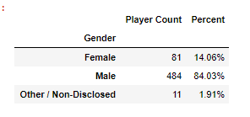

2) demographically, 20-24 year olds have the most players and as a group also spend the most on additional purchases

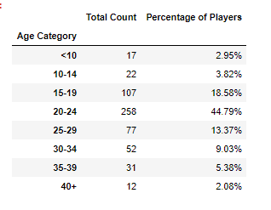

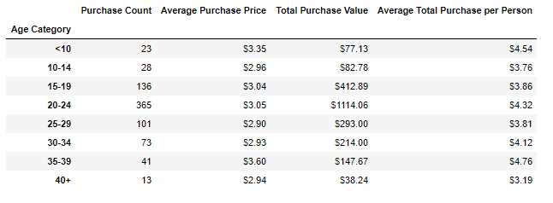

3) The game “Final Critic” brought in the purchases – but only amounting to $59.99 over 13 purchases.

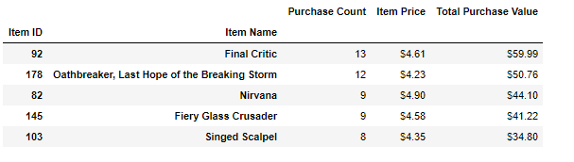

## Summary

My advice to the company if they wanted to know how to make additional money off purchases would be to focus on men 20-24 years old. The specific game itself does not appear to be a significant influence. This demographic information seems logical as well as men that age likely have some expendable income (unlike 10 year olds) and time to play (unlike those 25+ who may be more focused on career or family).